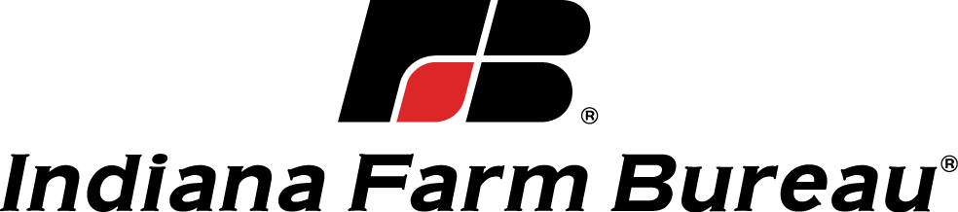

2019 Ag Education and Promotion Development Grant
Sponsored by the Indiana Farm Bureau Women’s Leadership Committee

Purpose: The purpose of this program is to provide assistance to county Farm Bureaus, Farm Bureau members and educators that do not have adequate funds for a new program, activity, or to attend an event that would enhance the promotion of agriculture and education. Program examples could include, but are not limited to books for classrooms, incubator systems, supplies for school gardens, etc. Events could include, but are not limited to the National Ag in the Classroom Conference, AFBF Women’s Communication Boot Camp, summer educational programs, specialized educational conferences, etc. Please provide sufficient details/information about your program to give the judges a clear picture of your plans/expectations.

Application Process: An application form must be completed by the county Farm Bureau, Farm Bureau member or educator. The form must be signed by the county president and/or county education and outreach coordinator and submitted to the INFB home office via email at odt@infarmbureau.org. A grant committee will review all applications and approve funds based on financial need and the potential impact of the program in reaching organizational goals.
*Application must be typed.

Grant Amount: Indiana Farm Bureau will award grants of up to $250 to winning applicants.

Qualified Programs/Activities: The program or activity must be new. Existing programs or activities that are being significantly changed and/or expanded may also qualify. Individuals who would like to attend a conference or event must show the value of why they should attend the event and how it will enhance what they do when they return.

Deadline: There will be two application periods. First round grant applications must be submitted by January 31st and winners will be announced at Spring Conference in March. The second deadline is May 1st and winners will be announced at the Ag in the Classroom Workshop in June. All applications are due to the home office by 4:30 p.m. (eastern) on the due date. If your application is not selected the first time, it can be resubmitted the next application period.

Follow Up: Applicants that are awarded a grant have 30 days following the event to complete a closing report. These reports and success stories will be shared.

Ag Education and Promotion Development Grant

Date

County

Person or county completing application:

Phone: Email:

County Farm Bureau President (signature):

and/or

County Education and Outreach Coordinator (signature):

What are you applying for:
- County seeking funds for AITC program
- Educator seeking funds to enhance Agriculture in the Classroom
- Farm Bureau member seeking funds to attend a conference or event
- Educator seeking funds to attend a conference or event

Describe Program, Activity, or Event

Purpose of the Program/Activity/Event

Who is the target audience for this program/activity/event?

Will this be a one time program/activity or will it be an ongoing program?

If this will be an ongoing program/activity will you have adequate funding to continue? (Explain)

Is this an existing program/activity that will be expanded or improved? If so please explain the changes/improvements?

Is this a program or activity that could be shared and conducted in other counties?

How many volunteers do you expect to involve or people do you expect to reach with this program/activity?

If attending an event what do you hope to achieve by attending?

If attending an event, how do you plan to apply what you have learned at the event?

What is the estimated total cost of this program/activity/event? (list major program components and costs)

Will the County Farm Bureau contribute toward the program/event and if so how much? (money and other resources)

Will any other organizations, groups, or companies contribute toward the program/event? (list expected amounts)

Briefly describe the most important reason you feel this request should receive an
Indiana Farm Bureau Ag Education and Promotion Development Grant?

Amount of money requested from INFB for this program/activity/event (Maximum $250)

Signature of person completing form:____________________________________________

Email Address:_____________________________________________________________

Brief bio/background of person completing form:

Counties and individuals awarded a grant will need to complete a final project report after the program is completed.

