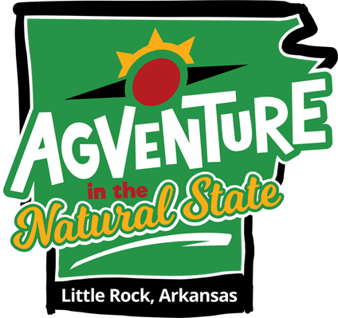
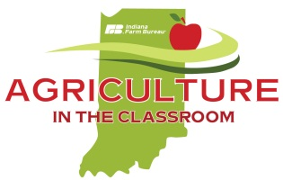
Application to Attend
National Agriculture in the Classroom Conference
Little Rock, Arkansas • June 18-21, 2019

County Agriculture in the Classroom Volunteer
$800 Scholarship Application
Agriculture in the Classroom (AITC) provides educators a wealth of resources for integrating agriculture, nutrition and natural resource education into the K-12 curriculum. AITC programs improve student achievement by using innovative, hands-on, relatable lessons that intrigue students while teaching core curriculum concepts in science, social studies, language arts, math and nutrition. This conference showcases the best ideas and latest resources from across the country - ready for the classroom.
Scholarship Details: AITC volunteers that are interested in attending the National Agriculture in the Classroom conference in Little Rock, Arkansas may apply to receive an $800 Scholarship.
- Selected recipients may seek reimbursement up to $800 to aide in the cost of the conference registration; travel expenses to and from the conference; and/or lodging at the conference hotel.
- Expenses not eligible for reimbursement: Meals not included in the conference registration, books or other materials purchased, souvenirs, parking, mileage to/from the airport, shuttle/cab. Registration, lodging and/or travel expenses associated with the conference in excess of $800 are the individual’s responsibility. The recipient is responsible for paying miscellaneous expenses.
- Scholarship recipients are responsible for making their own hotel reservations and travel arrangements as well as registering for the conference; and submitting reimbursement request within 30 days of the conference.

Conference Information: www.agclassroom.org/conferences/index.htm (available in early 2019)

Scholarship Eligibility: The AITC volunteer must have a completed volunteer registration and signed code of conduct on file with the Indiana Farm Bureau AITC program. Volunteer must also have submitted at least one classroom or event presentation record sheet for 2018 to be eligible for scholarship award.

Scholarship recipients will be announced at the 2019 INFB Spring Conference at the Marriott East in Indianapolis. (Recipients do not have to be present and will be informed via phone or email the following week.)

Scholarship Accountability:
- Recipients must complete an after-conference report which includes writing a guest social media post that includes up to 10 photos (video is optional) that will be posted on the Indiana Farm Bureau Facebook page after the conference. Post Conference and social media posts are required in order to be reimbursed for eligible expenses.

Selection Criteria:
Select members of INFB Women’s Leadership Committee and INFB staff will evaluate applications. Each evaluator will be asked to score the applications according to the following criteria:
- Applicant describes in detail the importance of embedding agricultural literacy in his/her curriculum. (20 pts)
- Applicant communicates valid and unique reason(s) for why he/she wants to attend the conference. (30 pts)
- Applicant explains how the experiences gained will be used after the conference (20 pts).
- Applicant is actively engaged in their county AITC program (30 points)

Email completed application to inaitc@infb.org by midnight February 1, 2019. No late, postal mail or fax entries accepted.  

Applications must be TYPED and received via email by midnight February 1, 2019. No late entries accepted.

2019 National AITC Conference • Volunteer Scholarship Application

Personal Information:
Name: |  |  |  |  |  |  |  |  | Membership County:
Phone: |  |  |  | Email:
Address:
Have you previously attended the National AITC Conference? |  |  |  |  |  |  |  |  |  |  | If yes, last year attended?
Number of Years as an AITC Volunteer: |  |  |  |  | Grade(s) or subjects presented to most often:
Number of times per year you make  presentations to students or youth organizations: |  |  |  |  |  |  |  |  |  | Approx. number of students reached with presentations in 2018

- Why do you believe it is important for students to have knowledge about modern agriculture and farming?
- Describe your AITC programming. What presentations do you make most often? What opportunities do you believe are available in your local community to grow your county’s AITC program?
- How do you plan to integrate the information and experiences gained from the conference in the classroom during the 2019-2020 school year?
- Why would you like to attend that 2019 National AITC Conference in Little Rock, Arkansas?

