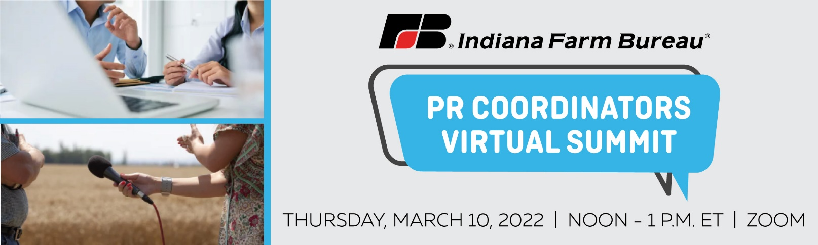

* **PR Best Practices** 
  + Media Materials: Drafting an effective press release and media alert.
    - Heidi Gant, INFB PR manager - public policy, will review the basics of writing a media alert/press release and lead the group in drafting media materials for an upcoming county event.
  + Media Relations: How to pitch your story or event to reporters and get coverage.
    - Colleen Baker, INFB PR manager – brand, will go over how to find the best reporter in your county to cover your event and lead the group in drafting a pitch email for an upcoming event.
* **Social Media Tips** 
  + Garrett Kelly, INFB managing editor of digital and video content, will share helpful social media tips including what to share, how to engage with your audience and what mistakes to avoid on social media.
* **Available Resources**
  + Colleen Baker and Cheyenne Dunn, INFB county marketing coordinator, will share how the INFB marketing team can assist in promoting your next event.
* **Discussion and Q&A**